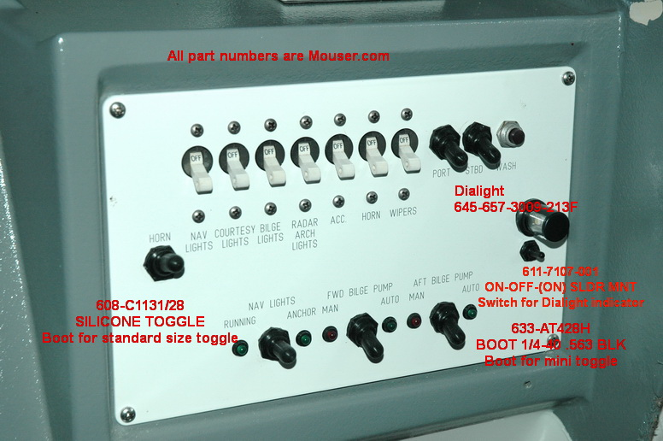

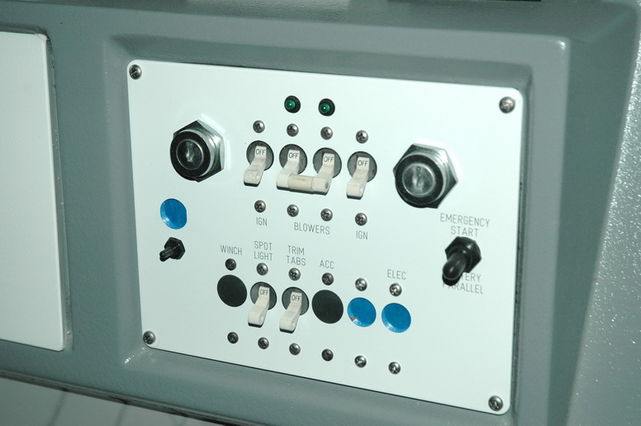

These are the panel indicators. For 12v you have to wire a 400 ohm ¼ watt current limiting resistor in series with each one. They are quite bright. Maybe an 800 ohm would be better. The originals were very dim.

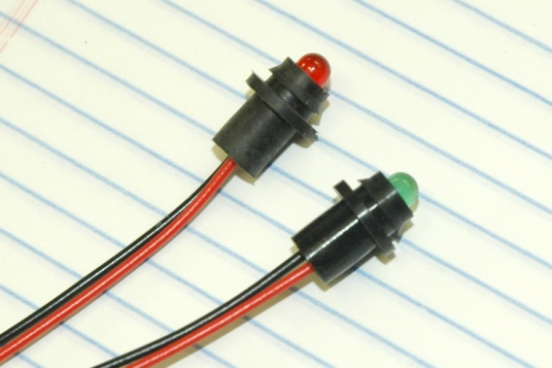

Boots:

<http://www.mouser.com/Search/ProductDetail.aspx?R=AT428Hvirtualkey63300000virtualkey633-AT428H>

<http://www.mouser.com/Search/ProductDetail.aspx?R=C1131%2f28virtualkey60820000virtualkey608-C1131%2f28>

Mini Toggle

<http://www.mouser.com/Search/ProductDetail.aspx?R=7107SYZQEvirtualkey61170000virtualkey611-7107-001>

Speaker transfer switch

<http://www.mouser.com/Search/ProductDetail.aspx?R=S6F-ROvirtualkey63300000virtualkey633-S6F-RO>